How to get ssh key

-> Go to Command prom

- cd. ssh

- ls

- cat id rsa.pub

Run in docker (Exce)

- npm run seeder

How to run Mobile app

1. Download Android Studio & Flutter
2. Extras file flutter
3. Copy: Local C/:flutter window 8.4.0/:flutter/:bin
4. Past in Edit environment in above and under
5. Install Android Studio (Around 20 – 30 minutes)
6. Picture of successful install

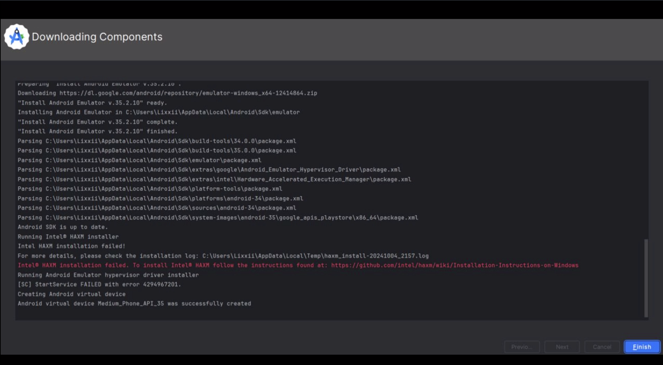

1. Go into Android Studio ->More Action ->SDK Manager ->SDK Tools
2. 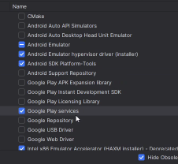
3. -> More Action -> Virtual Devised Manager
4. Go to Sum sign -> Pixel 8 -> Install R -> click finish -> click run Phone Pixel 8
5. Go to Visal code -> install flutter ->run flutter in mobile app in visal code
6. Cd mobile -> run command :flutter doctor
7. If it don’t know the environment please restart ur computer
8. Flutter run
9. Goto flutter icon in visual code
10. Back cmd: flutter pub get
11. Go to android phone ->go to notification flutter ->click finish setup ->start -> Next ->don’t copy ->skip ->skip -> No thank
12. Cmd: flutter run (wait more minutes)
13. Go to Android mobile ->open app – phone number: 0889566929

* Password: 123456

1. Finish
2. Connect with others sever cd : flutter run –d application

How to Deploy POS V2